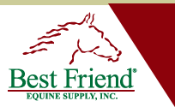


Prevention is always better than cure!

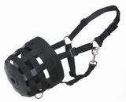

Finding the right size Best Friend Muzzle is as easy as A-B-C:

The Best Friend Grazing Muzzle® comes in 6 sizes:
- Mini
- Pony
- Cob
- Horse
- Large Horse
(6. Draft - pre-order only)

If you know your horse’s normal halter size, you have got a good starting point. Now make sure that the “muzzle basket” will fit correctly
(Note: Your Delux Grazing Muzzle will come with a break-away safety halter!)
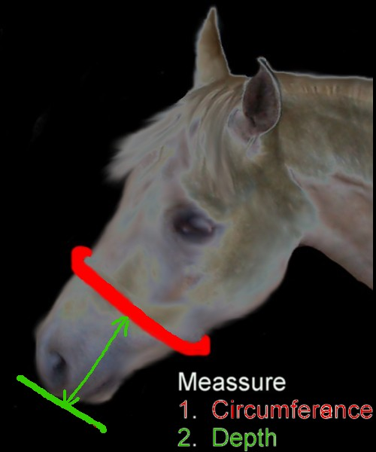
- Take a tape measure
(or a piece of string) to gently
measure the circumference of
your horse’s nose (see red line)

- Then measure the depth
from where you have taken
the circumference measure
down to the level of your horse’s lips
(see green line).

Now ADD the width of a bout 2-3
fingers to each of the measurements,
so there will be enough sideways
room for the horse to chew,
as well as space between the bottom
of the muzzle and the horse’s lips.

According to your “spacy” end result, choose the closest

actual muzzle size :
(the manufacturer’s muzzle sizes are in inches, but I have included metric measures for your convenience)
Circumference 20” / 5.5” Depth  (50.8cm / 13.97cm) | Mini (fits larger Minis, small Shetlands)
Circumference 22”/5 3/4” Depth  55.88cm / 14.60cm | Pony (average size Ponies)
Circumference 23” / 7” Depth  58.42cm / 17.78cm | Cob (large Ponies, Cobs, Horses with smaller, thinner faces, such as Arabs)
Circumference 26” / 7.5” Depth  66.04cm / 19.05cm | Horse (average size horse)
Circumference 28” / 8” Depth  71.12cm / 20.32cm | Large Horse (such as Warmbloods or horses with larger faces)

