HEALTHY BARE HOOVES…
…have got some things in common:

They have…..
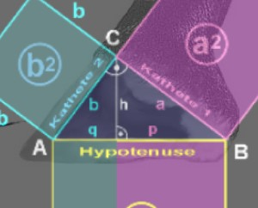
1. A sound, pain-free owner,
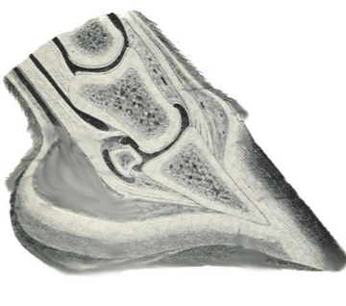 2. Balance and function.
3. Hoofmechanism
4. Ground parallel coffin bones
5. Functioning, non-invasive bars
6. Correct break-over

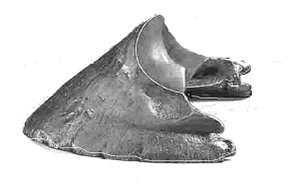 7. Correct angles
8. Solar concavity
- How much do I really know about my horse’s hooves?
- Why is there such a fuss about “barefoot”?
- What is “soundness” compared to “absence of lameness”?
- Is shoeing a “necessary evil”?
- What is - and what is not “peripheral loading”?
- What is the difference between a “farrier trim”, some “barefoot trims” and a physiologically correct trim?
- Is my farrier/trimmer doing a good job?
- Why is the hoof a metabolic organ and what are its functions?
- Why and how is 60-80% of concussion absorbed by the hoof and what happens when a shoe is attached?
- Do Thoroughbreds have notoriously bad feet?
- What is “Navicular”? “Laminitis”? “Pedalosteitis”? “Thrush”? “Seedy Toe”?…
- Is Founder (separation and rotation of the coffin bone) reversible?
- Are crack or rings in the hoof wall normal?
- Why is water better for my horse’s hooves than grease or oil?
- What is the truth about a “Mustang roll”. Should you “mustang roll” or not? What if you have a Warmblood, living in a grass paddock?
- AND MUCH MORE

9. Tactile Ability
10. Hydration
THIS IS KNOWLEDGE EVERY
HORSE OWNER MUST HAVE
If you are interested in learning the answers to
these questions and much, much more -
AND want to get actively involved in maintaining
your horse’s hooves healthy
(learn “maintenance trimming”), enrol in a
“Equine Bare Hoof Care Original“ workshop with
Naturopathic Equine Podiatrist (NEP) and Hoofcare Coach
Carola “Yarraman” Adolf

Carola Adolf, NEP/fSHP
is a Naturopathic Equine Podiatrist and Master
trimmer. She graduated through the German
“Institut für Hufgesundheit und Ganzheitliche
Pferdebehandlung” in 2003. Carola is also a
National Accredited Level IV Workplace Trainer
and Assessor, TAFE Mentor, Equine Soundness
School instructor as well as an
accredited Dressage instructor and EA Dressage
judge(now ret.) She has been working with
Equines most of her life, and only in recent years
(her own horse became very ill with founder) became a passionate barehoof advocate. After her studies with Dr. Strasser and continued education over the past decade (via conventional as well as holistic Equine hoof-and health care sources ), she has travelled all over Australia to help rehabilitate unsound horses. Besides her busy practice in Victoria and looking after her own horses, she offers quarterly in-depth seminars, workshops and clinics on equine health- and hoofcare for all who want to learn more about a modern, holistic approach to horse husbandry and physiologically correct hoof maintenance and rehabilitation. Do not miss out learning from one of the first and leading, experienced barehoof practitioners in Australia!
Professional trimmers (TAFE students!), farriers and other equine professionals, and of course, interested horse owners, are more than welcome!

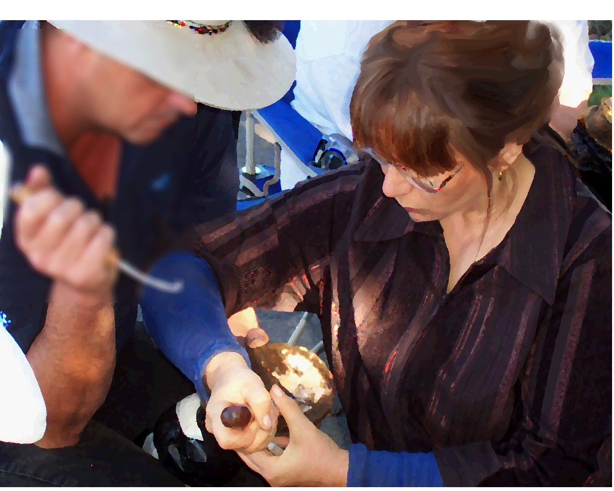
begin_of_the_skype_highlighting Casual hoof care workshop
“Keep your Socks on”
When: 4th and 5th of October 2014
Where: Lot 9, Acton Road Bass
(between Abby’s shed and the Giant Worm... use U-turn after Caltex Petrol station, 10km past Grantville on the way to Philip Island)
Time : 9am – when we finish
Tea, Coffee, biscuits supplied, bring your own lunch – McDonalds at the Caltex Service Sation!)
Program – Saturday THEORY
Sunday PRACTICAL
trimming/cadavers
Bring your tools, if you have any. If not, I sell tools and provide loan tools for the workshop.
Cost: $300 per person for both days (or invite) Register with $50 non refundable deposit by 26th of September, balance on the day!
Westpac BSB 733-003 Acc 58-2462
003 Account No FREE end_of_the_skype_highlighting. 58-2462

To find out more about the most comprehensive owner-trimmer course in Australia which offers follow-up training options and hoofcare coaching and mentoring
www.EquineBareHoofCare.org
or contact us if you are interested in hosting a great learning experience !
We are always looking for seminar organizers
Hoof.care@bigpond.com
0437 483 243

